UNIT I- LEXICAL ANALYSIS

INRODUCTION TO COMPILING

Translator:
It is a program that translates one language to another.

source code | Translator | target code
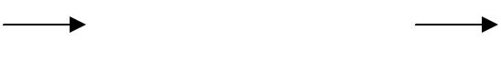
Types of Translator:
1.Interpreter
2.Compiler
3.Assembler

1.Interpreter:
It is one of the translators that translate high level language to low level language.

high level language | Interpreter | low level language
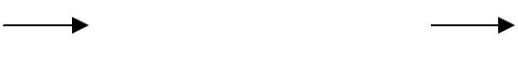
During execution, it checks line by line for errors.
Example: Basic, Lower version of Pascal.

2.Assembler:
It translates assembly level language to machine code.

assembly language |  | machine code
assembly language | Assembler | machine code
Example: Microprocessor 8085, 8086.
3.Compiler:
It is a program that translates one language(source code) to another language (target

code).

source code |  | target code
source code | Compiler | target code
It executes the whole program and then displays the errors.
Example: C, C++, COBOL, higher version of Pascal.

Difference between compiler and interpreter:

Compiler

It is a translator that translates high level to low level language
It displays the errors after the whole program is executed.

Interpreter

It is a translator that translates high level to low level language
It checks line by line for errors.

Examples: Basic, lower version of Pascal. | Examples: C, C++, Cobol, higher version of
 | Pascal.

PARTS OF COMPILATION

There are 2 parts to compilation:
- Analysis
- Synthesis

Analysis part breaks down the source program into constituent pieces and creates an intermediate representation of the source program.

Synthesis part constructs the desired target program from the intermediate representation.

source code
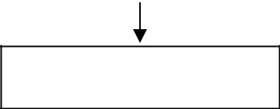

Analysis

intermediate code

Synthesis

object code

Software tools used in Analysis part:

- Structure editor:

  - Takes as input a sequence of commands to build a source program.
  - The structure editor not only performs the text-creation and modification functions of an ordinary text editor, but it also analyzes the program text, putting an appropriate hierarchical structure on the source program.

  - For example , it can supply key words automatically - while …. do and begin….. end.

- Pretty printers :

  - A pretty printer analyzes a program and prints it in such a way that the structure of the program becomes clearly visible.

  - For example, comments may appear in a special font.

- Static checkers :

  - A static checker reads a program, analyzes it, and attempts to discover potential bugs without running the program.

  - For example, a static checker may detect that parts of the source program can never be executed.

- Interpreters :

  - Translates from high level language ( BASIC, FORTRAN, etc..) into machine language.
  - An interpreter might build a syntax tree and then carry out the operations at the nodes as it walks the tree.

  - Interpreters are frequently used to execute command language since each operator executed in a command language is usually an invocation of a complex routine such as an editor or complier.

ANALYSIS OF THE SOURCE PROGRAM

Analysis consists of 3 phases:

Linear/Lexical Analysis :

- It is also called scanning. It is the process of reading the characters from left to right and grouping into tokens having a collective meaning.

- For example, in the assignment statement a=b+c*2, the characters would be grouped into the following tokens:
  - The identifier1 ‘a’
  - The assignment symbol (=)
  - The identifier2 ‘b’
  - The plus sign (+)
  - The identifier3 ‘c’
  - The multiplication sign (*)
  - The constant ‘2’

Syntax Analysis :

- It is called parsing or hierarchical analysis. It involves grouping the tokens of the source program into grammatical phrases that are used by the compiler to synthesize output.

- They are represented using a syntax tree as shown below:

=
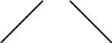
a +
b *

  - 2

- A syntax tree is the tree generated as a result of syntax analysis in which the interior nodes are the operators and the exterior nodes are the operands.

- This analysis shows an error when the syntax is incorrect.

Semantic Analysis :

- It checks the source programs for semantic errors and gathers type information for the subsequent code generation phase. It uses the syntax tree to identify the operators and operands of statements.

- An important component of semantic analysis is type checking. Here the compiler checks that each operator has operands that are permitted by the source language specification.

PHASES OF COMPILER

A Compiler operates in phases, each of which transforms the source program from one representation into another. The following are the phases of the compiler:

Main phases:

- Lexical analysis
- Syntax analysis
- Semantic analysis
- Intermediate code generation
- Code optimization
- Code generation

Sub-Phases:

- Symbol table management
- Error handling
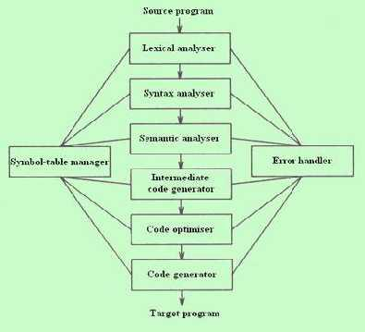

LEXICAL ANALYSIS:

- It is the first phase of the compiler. It gets input from the source program and produces tokens as output.

- It reads the characters one by one, starting from left to right and forms the tokens.
- Token : It represents a logically cohesive sequence of characters such as keywords, operators, identifiers, special symbols etc.
Example: a + b = 20
Here, a,b,+,=,20 are all separate tokens.
Group of characters forming a token is called the Lexeme.

- The lexical analyser not only generates a token but also enters the lexeme into the symbol table if it is not already there.

SYNTAX ANALYSIS:

- It is the second phase of the compiler. It is also known as parser.
- It gets the token stream as input from the lexical analyser of the compiler and generates syntax tree as the output.

- Syntax tree:
It is a tree in which interior nodes are operators and exterior nodes are operands.

- Example: For a=b+c*2, syntax tree is

=
a +
b *
c 2

SEMANTIC ANALYSIS:

- It is the third phase of the compiler.
- It gets input from the syntax analysis as parse tree and checks whether the given syntax is correct or not.

- It performs type conversion of all the data types into real data types.

INTERMEDIATE CODE GENERATION:

- It is the fourth phase of the compiler.
- It gets input from the semantic analysis and converts the input into output as intermediate code such as three-address code.

- The three-address code consists of a sequence of instructions, each of which has atmost three operands.
Example: t1=t2+t3

CODE OPTIMIZATION:

- It is the fifth phase of the compiler.

- It gets the intermediate code as input and produces optimized intermediate code as output.

- This phase reduces the redundant code and attempts to improve the intermediate code so that faster-running machine code will result.

- During the code optimization, the result of the program is not affected.
- To improve the code generation, the optimization involves
  - deduction and removal of dead code (unreachable code).
  - calculation of constants in expressions and terms.
  - collapsing of repeated expression into temporary string.
  - loop unrolling.
  - moving code outside the loop.
  - removal of unwanted temporary variables.

CODE GENERATION:

- It is the final phase of the compiler.
- It gets input from code optimization phase and produces the target code or object code as result.

- Intermediate instructions are translated into a sequence of machine instructions that perform the same task.

- The code generation involves
  - allocation of register and memory
  - generation of correct references
  - generation of correct data types
  - generation of missing code

SYMBOL TABLE MANAGEMENT:

- Symbol table is used to store all the information about identifiers used in the program.
- It is a data structure containing a record for each identifier, with fields for the attributes of the identifier.

- It allows to find the record for each identifier quickly and to store or retrieve data from that record.

- Whenever an identifier is detected in any of the phases, it is stored in the symbol table.

ERROR HANDLING:

- Each phase can encounter errors. After detecting an error, a phase must handle the error so that compilation can proceed.

- In lexical analysis, errors occur in separation of tokens.

- In syntax analysis, errors occur during construction of syntax tree.
- In semantic analysis, errors occur when the compiler detects constructs with right syntactic structure but no meaning and during type conversion.

- In code optimization, errors occur when the result is affected by the optimization.
- In code generation, it shows error when code is missing etc.

To illustrate the translation of source code through each phase, consider the statement a=b+c*2. The figure shows the representation of this statement after each phase:

Symbol Table

- id1

- id2

- id3
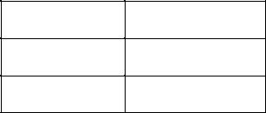
a=b+c*2
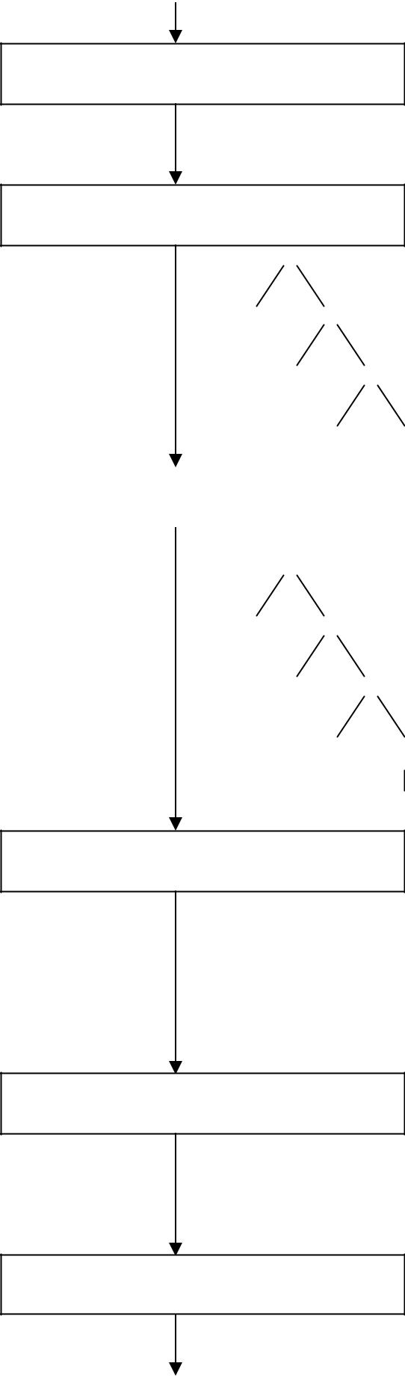

Lexical analyser

id1=id2+id3*2

Syntax analyser

=

id1 +

id2 *

id3 2

Semantic analyser | =
 | =

id1 +

id2 *

id3 inttoreal

2

Intermediate code generator

temp1=inttoreal(2)
temp2=id3*temp1
temp3=id2+temp2
id1=temp3

Code optimizer

temp1=id3*2.0
id1=id2+temp1

Code generator

MOVF id3,R2
MULF #2.0,R2
MOVF id2,R1
ADDF R2,R1
MOVF R1,id1

COUSINS OF COMPILER
- Preprocessor
- Assembler
- Loader and Link-editor

PREPROCESSOR
A preprocessor is a program that processes its input data to produce output that is used as input to another program. The output is said to be a preprocessed form of the input data, which is often used by some subsequent programs like compilers.
They may perform the following functions :
- Macro processing
- File Inclusion
- Rational Preprocessors
- Language extension

1. Macro processing:
A macro is a rule or pattern that specifies how a certain input sequence should be mapped to an output sequence according to a defined procedure. The mapping process that instantiates a macro into a specific output sequence is known as macro expansion.

2. File Inclusion:
Preprocessor includes header files into the program text. When the preprocessor finds an #include directive it replaces it by the entire content of the specified file.

3. Rational Preprocessors:
These processors change older languages with more modern flow-of-control and data-structuring facilities.

4. Language extension :
These processors attempt to add capabilities to the language by what amounts to built-in macros. For example, the language Equel is a database query language embedded in C.

ASSEMBLER
Assembler creates object code by translating assembly instruction mnemonics into machine code. There are two types of assemblers:

- One-pass assemblers go through the source code once and assume that all symbols will be defined before any instruction that references them.

- Two-pass assemblers create a table with all symbols and their values in the first pass, and then use the table in a second pass to generate code.

LINKER AND LOADER
A linker or link editor is a program that takes one or more objects generated by a compiler and combines them into a single executable program.
Three tasks of the linker are :
- Searches the program to find library routines used by program, e.g. printf(), math routines.
- Determines the memory locations that code from each module will occupy and relocates its instructions by adjusting absolute references
- Resolves references among files.

A loader is the part of an operating system that is responsible for loading programs in memory, one of the essential stages in the process of starting a program.

GROUPING OF THE PHASES

Compiler can be grouped into front and back ends:

- Front end: analysis (machine independent)

These normally include lexical and syntactic analysis, the creation of the symbol table, semantic analysis and the generation of intermediate code. It also includes error handling that goes along with each of these phases.

- Back end: synthesis (machine dependent)

It includes code optimization phase and code generation along with the necessary error handling and symbol table operations.

Compiler passes

A collection of phases is done only once (single pass) or multiple times (multi pass)

- Single pass: usually requires everything to be defined before being used in source program.

- Multi pass: compiler may have to keep entire program representation in memory.

Several phases can be grouped into one single pass and the activities of these phases are interleaved during the pass. For example, lexical analysis, syntax analysis, semantic analysis and intermediate code generation might be grouped into one pass.

COMPILER CONSTRUCTION TOOLS

These are specialized tools that have been developed for helping implement various phases of a compiler. The following are the compiler construction tools:

- Parser Generators:

-These produce syntax analyzers, normally from input that is based on a context-free grammar.
-It consumes a large fraction of the running time of a compiler. -Example-YACC (Yet Another Compiler-Compiler).

- Scanner Generator:

-These generate lexical analyzers, normally from a specification based on regular expressions. -The basic organization of lexical analyzers is based on finite automation.

- Syntax-Directed Translation:

-These produce routines that walk the parse tree and as a result generate intermediate code. -Each translation is defined in terms of translations at its neighbor nodes in the tree.

- Automatic Code Generators:

-It takes a collection of rules to translate intermediate language into machine language. The rules must include sufficient details to handle different possible access methods for data.

- Data-Flow Engines:

-It does code optimization using data-flow analysis, that is, the gathering of information about how values are transmitted from one part of a program to each other part.

LEXICAL ANALYSIS

Lexical analysis is the process of converting a sequence of characters into a sequence of tokens. A program or function which performs lexical analysis is called a lexical analyzer or scanner. A lexer often exists as a single function which is called by a parser or another function.

THE ROLE OF THE LEXICAL ANALYZER

- The lexical analyzer is the first phase of a compiler.
- Its main task is to read the input characters and produce as output a sequence of tokens that the parser uses for syntax analysis.

 |  | token
source | lexical | token | parser
program | analyser | get next token
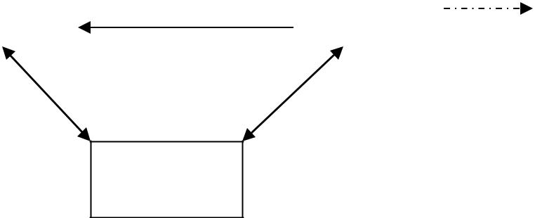

symbol table

- Upon receiving a “get next token” command from the parser, the lexical analyzer reads input characters until it can identify the next token.

ISSUES OF LEXICAL ANALYZER

There are three issues in lexical analysis:

- To make the design simpler.
- To improve the efficiency of the compiler.

- To enhance the computer portability.

TOKENS

A token is a string of characters, categorized according to the rules as a symbol (e.g., IDENTIFIER, NUMBER, COMMA). The process of forming tokens from an input stream of characters is called tokenization.
A token can look like anything that is useful for processing an input text stream or text file. Consider this expression in the C programming language: sum=3+2;

Lexeme | Token type
sum | Identifier
= | Assignment operator
3 | Number
+ | Addition operator
2 | Number
; | End of statement

LEXEME:

Collection or group of characters forming tokens is called Lexeme.

PATTERN:

A pattern is a description of the form that the lexemes of a token may take.

In the case of a keyword as a token, the pattern is just the sequence of characters that form the keyword. For identifiers and some other tokens, the pattern is a more complex structure that is matched by many strings.

Attributes for Tokens

Some tokens have attributes that can be passed back to the parser. The lexical analyzer collects information about tokens into their associated attributes. The attributes influence the translation of tokens.

- Constant : value of the constant
- Identifiers: pointer to the corresponding symbol table entry.

ERROR RECOVERY STRATEGIES IN LEXICAL ANALYSIS:

The following are the error-recovery actions in lexical analysis:

- Deleting an extraneous character.

- Inserting a missing character.

- Replacing an incorrect character by a correct character.

- Transforming two adjacent characters.

- Panic mode recovery: Deletion of successive characters from the token until error is resolved.

INPUT BUFFERING

We often have to look one or more characters beyond the next lexeme before we can be sure we have the right lexeme. As characters are read from left to right, each character is stored in the buffer to form a meaningful token as shown below:

Forward pointer
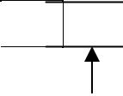
A = B + C

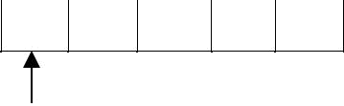

Beginning of the token Look ahead pointer

We introduce a two-buffer scheme that handles large look aheads safely. We then consider an improvement involving "sentinels" that saves time checking for the ends of buffers.

BUFFER PAIRS

- A buffer is divided into two N-character halves, as shown below

  - : E : : = : : M : * C : * : : * : 2 : eof
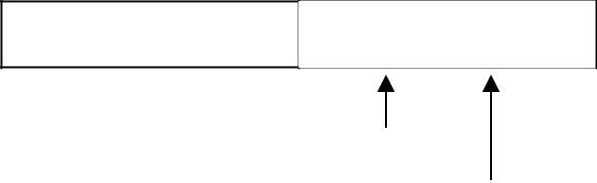

lexeme_beginning forward

- Each buffer is of the same size N, and N is usually the number of characters on one disk block. E.g., 1024 or 4096 bytes.

- Using one system read command we can read N characters into a buffer.
- If fewer than N characters remain in the input file, then a special character, represented by eof, marks the end of the source file.

- Two pointers to the input are maintained:
  - Pointer lexeme_beginning, marks the beginning of the current lexeme, whose extent we are attempting to determine.
  - Pointer forward scans ahead until a pattern match is found.

Once the next lexeme is determined, forward is set to the character at its right end.
- The string of characters between the two pointers is the current lexeme.
After the lexeme is recorded as an attribute value of a token returned to the parser, lexeme_beginning is set to the character immediately after the lexeme just found.

Advancing forward pointer:

Advancing forward pointer requires that we first test whether we have reached the end of one of the buffers, and if so, we must reload the other buffer from the input, and move forward to the beginning of the newly loaded buffer. If the end of second buffer is reached, we must again reload the first buffer with input and the pointer wraps to the beginning of the buffer.

Code to advance forward pointer:

if forward at end of first half then begin reload second half;
forward := forward + 1
end
else if forward at end of second half then begin reload second half;
move forward to beginning of first half
end
else forward := forward + 1;

SENTINELS

- For each character read, we make two tests: one for the end of the buffer, and one to determine what character is read. We can combine the buffer-end test with the test for the current character if we extend each buffer to hold a sentinel character at the end.

- The sentinel is a special character that cannot be part of the source program, and a natural choice is the character eof.

- The sentinel arrangement is as shown below:

  - : E : : = : : M : * : eofC : * : : * : 2 : eof : : : eof
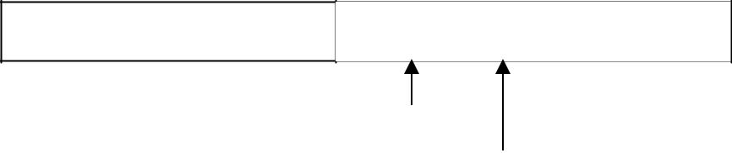

lexeme_beginning forward

Note that eof retains its use as a marker for the end of the entire input. Any eof that appears other than at the end of a buffer means that the input is at an end.

Code to advance forward pointer:

forward : = forward + 1;
if forward ↑ = eof then begin
if forward at end of first half then begin reload second half;
forward := forward + 1
end
else if forward at end of second half then begin reload first half;
move forward to beginning of first half end
else /* eof within a buffer signifying end of input */ terminate lexical analysis
end

SPECIFICATION OF TOKENS

There are 3 specifications of tokens:
- Strings
- Language
- Regular expression

Strings and Languages

An alphabet or character class is a finite set of symbols.

A string over an alphabet is a finite sequence of symbols drawn from that alphabet.

A language is any countable set of strings over some fixed alphabet.

In language theory, the terms "sentence" and "word" are often used as synonyms for "string." The length of a string s, usually written |s|, is the number of occurrences of symbols in s. For example, banana is a string of length six. The empty string, denoted ε, is the string of length zero.

Operations on strings

The following string-related terms are commonly used:

- A prefix of string s is any string obtained by removing zero or more symbols from the end of string s.

For example, ban is a prefix of banana.

- A suffix of string s is any string obtained by removing zero or more symbols from the beginning of s.
For example, nana is a suffix of banana.

- A substring of s is obtained by deleting any prefix and any suffix from s. For example, nan is a substring of banana.

- The proper prefixes, suffixes, and substrings of a string s are those prefixes, suffixes, and substrings, respectively of s that are not ε or not equal to s itself.

- A subsequence of s is any string formed by deleting zero or more not necessarily consecutive positions of s.
For example, baan is a subsequence of banana.

Operations on languages:

The following are the operations that can be applied to languages:

1.Union
2.Concatenation 3.Kleene closure 4.Positive closure

The following example shows the operations on strings:

Let L={0,1} and S={a,b,c}
1. | Union | : L U S={0,1,a,b,c}
2. | Concatenation | : L.S={0a,1a,0b,1b,0c,1c}
3. | Kleene closure | : L*={ ε,0,1,00….}
4. | Positive closure | : L⁺={0,1,00….}

Regular Expressions

Each regular expression r denotes a language L(r).

Here are the rules that define the regular expressions over some alphabet Σ and the languages that those expressions denote:

- ε is a regular expression, and L(ε) is { ε }, that is, the language whose sole member is the empty string.

- If ‘a’ is a symbol in Σ, then ‘a’ is a regular expression, and L(a) = {a}, that is, the language with one string, of length one, with ‘a’ in its one position.

- Suppose r and s are regular expressions denoting the languages L(r) and L(s). Then,

  - (r)|(s) is a regular expression denoting the language L(r) U L(s).
  - (r)(s) is a regular expression denoting the language L(r)L(s).
  - (r)* is a regular expression denoting (L(r))*.

  - (r) is a regular expression denoting L(r).

- The unary operator * has highest precedence and is left associative.

- Concatenation has second highest precedence and is left associative.

- | has lowest precedence and is left associative.

Regular set

A language that can be defined by a regular expression is called a regular set.
If two regular expressions r and s denote the same regular set, we say they are equivalent and write r = s.

There are a number of algebraic laws for regular expressions that can be used to manipulate into equivalent forms.
For instance, r|s = s|r is commutative; r|(s|t)=(r|s)|t is associative.

Regular Definitions

Giving names to regular expressions is referred to as a Regular definition. If Σ is an alphabet of basic symbols, then a regular definition is a sequence of definitions of the form

dl → r 1 d2 → r2

………
dn → rn

- Each di is a distinct name.
- Each ri is a regular expression over the alphabet Σ U {dl, d2,. . . , di-l}.

Example: Identifiers is the set of strings of letters and digits beginning with a letter. Regular definition for this set:
letter → A | B | …. | Z | a | b | …. | z | digit → 0 | 1 | …. | 9
id → letter ( letter | digit ) *

Shorthands

Certain constructs occur so frequently in regular expressions that it is convenient to introduce notational shorthands for them.

- One or more instances (+):

  - The unary postfix operator + means “ one or more instances of” .

  - If r is a regular expression that denotes the language L(r), then ( r )⁺ is a regular expression that denotes the language (L (r ))⁺

  - Thus the regular expression a⁺ denotes the set of all strings of one or more a’s.

  - The operator ⁺ has the same precedence and associativity as the operator *.

2. Zero or one instance ( ?):

- The unary postfix operator ? means “zero or one instance of”.

- The notation r? is a shorthand for r | ε.

- If ‘r’ is a regular expression, then ( r )? is a regular expression that denotes the language L( r ) U { ε }.

3. Character Classes:

- The notation [abc] where a, b and c are alphabet symbols denotes the regular expression a | b | c.

- Character class such as [a – z] denotes the regular expression a | b | c | d | ….|z.

- We can describe identifiers as being strings generated by the regular expression, [A–Za–z][A–Za–z0–9]*

Non-regular Set

A language which cannot be described by any regular expression is a non-regular set. Example: The set of all strings of balanced parentheses and repeating strings cannot be described by a regular expression. This set can be specified by a context-free grammar.

RECOGNITION OF TOKENS

Consider the following grammar fragment:

stmt → if expr then stmt
| if expr then stmt else stmt | ε

expr → term relop term | term

term → id | num

where the terminals if , then, else, relop, id and num generate sets of strings given by the following regular definitions:
if | → | if
then | → | then
else | → | else
relop | → | <|<=|=|<>|>|>=
id | → | letter(letter|digit)*
num | → | digit⁺ (.digit⁺)?(E(+|-)?digit⁺)?

For this language fragment the lexical analyzer will recognize the keywords if, then, else, as well as the lexemes denoted by relop, id, and num. To simplify matters, we assume keywords are reserved; that is, they cannot be used as identifiers.

Transition diagrams

It is a diagrammatic representation to depict the action that will take place when a lexical analyzer is called by the parser to get the next token. It is used to keep track of information about the characters that are seen as the forward pointer scans the input.
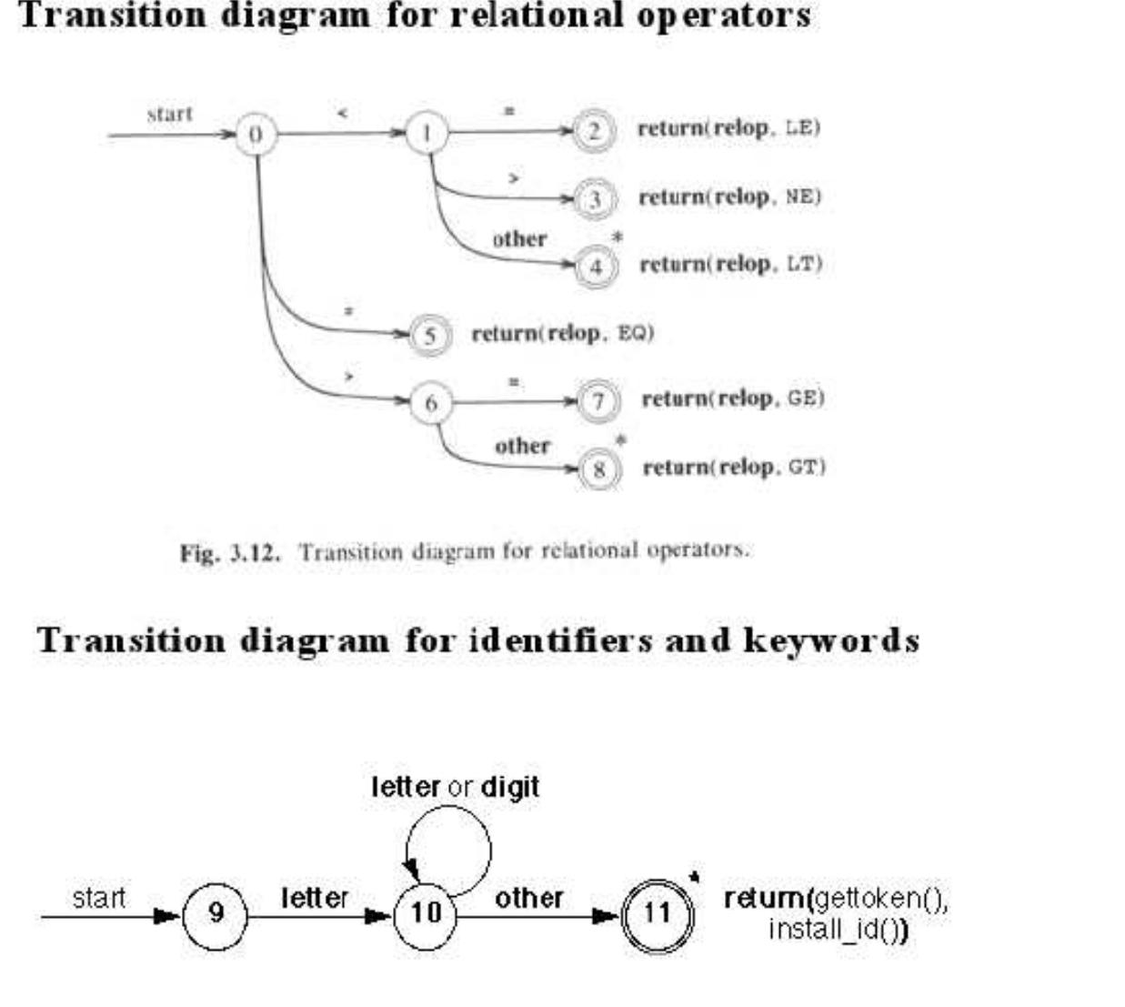

A LANGUAGE FOR SPECIFYING LEXICAL ANALYZER

There is a wide range of tools for constructing lexical analyzers.
- Lex
- YACC

LEX
Lex is a computer program that generates lexical analyzers. Lex is commonly used with the yacc parser generator.

Creating a lexical analyzer

- First, a specification of a lexical analyzer is prepared by creating a program lex.l in the Lex language. Then, lex.l is run through the Lex compiler to produce a C program lex.yy.c.

- Finally, lex.yy.c is run through the C compiler to produce an object program a.out, which is the lexical analyzer that transforms an input stream into a sequence of tokens.

lex.l | Lex | lex.yy.c
lex.l | compiler | lex.yy.c
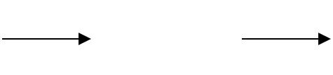

lex.yy.c | C compiler | a.out
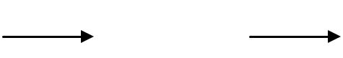

input | a.out | sequence of
stream |  | tokens
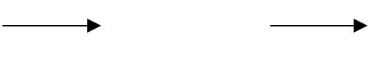

Lex Specification

A Lex program consists of three parts:

{ definitions }
%%
{ rules }
%%
{ user subroutines }

  - Definitions include declarations of variables, constants, and regular definitions

  - Rules are statements of the form p1 {action1}
p2 {action2}
…
pn {actionn}
where pi is regular expression and actioni describes what action the lexical analyzer should take when pattern pi matches a lexeme. Actions are written in C code.

  - User subroutines are auxiliary procedures needed by the actions. These can be compiled separately and loaded with the lexical analyzer.

YACC- YET ANOTHER COMPILER-COMPILER

Yacc provides a general tool for describing the input to a computer program. The Yacc user specifies the structures of his input, together with code to be invoked as each such structure is recognized. Yacc turns such a specification into a subroutine that handles the input process; frequently, it is convenient and appropriate to have most of the flow of control in the user's application handled by this subroutine.

FINITE AUTOMATA

Finite Automata is one of the mathematical models that consist of a number of states and edges. It is a transition diagram that recognizes a regular expression or grammar.

Types of Finite Automata

There are tow types of Finite Automata :

- Non-deterministic Finite Automata (NFA)
- Deterministic Finite Automata (DFA)

Non-deterministic Finite Automata

NFA is a mathematical model that consists of five tuples denoted by
M = {Qn, Ʃ, δ, q0, fn}

Qn | – finite set of states
Ʃ | – finite set of input symbols
δ | – transition function that maps state-symbol pairs to set of states
q0 | – | starting state
fn | – | final state

Deterministic Finite Automata

DFA is a special case of a NFA in which
- no state has an ε-transition.
- there is at most one transition from each state on any input.

DFA has five tuples denoted by
M = {Qd, Ʃ, δ, q0, fd}

Qd – finite set of states
- – finite set of input symbols
- – transition function that maps state-symbol pairs to set of states
q0 | – | starting state
fd | – | final state

Construction of DFA from regular expression

The following steps are involved in the construction of DFA from regular expression:
- Convert RE to NFA using Thomson’s rules
- Convert NFA to DFA
- Construct minimized DFA

